Command Prompt 1
Microsoft Windows [Version 10.0.19045.4170]
(c) Microsoft Corporation. All rights reserved.
C:\WINDOWS\system32>d:
D:\>javac *.java
D:\>rmic AdderRemote
Warning: generation and use of skeletons and static stubs for JRMP
is deprecated. Skeletons are unnecessary, and static stubs have
been superseded by dynamically generated stubs. Users are
encouraged to migrate away from using rmic to generate skeletons and static
stubs. See the documentation for java.rmi.server.UnicastRemoteObject.
D:\>rmiregistry 5000
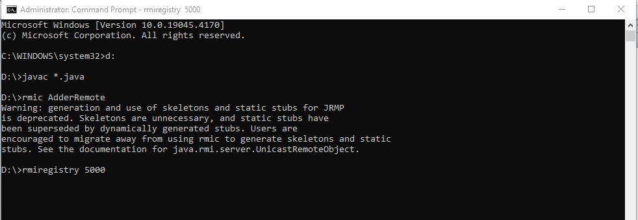

Command Prompt 2
Microsoft Windows [Version 10.0.19045.4170]
(c) Microsoft Corporation. All rights reserved.
C:\Users\Megharaj>d:
D:\>java MyServer

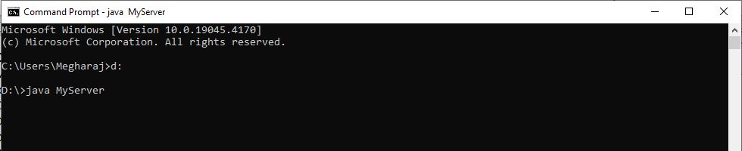

Command Prompt 3
Microsoft Windows [Version 10.0.19045.4170]
(c) Microsoft Corporation. All rights reserved.
C:\WINDOWS\system32>d:
D:\>java MyClient
38
D:\>

